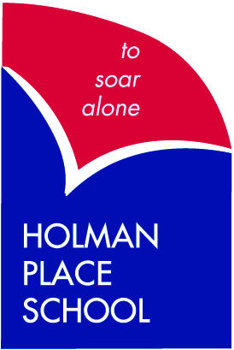

***A CENTRE OF QUALITY***

***SPECIALISED EDUCATION***

**NEW STUDENTS INFORMATION HANDBOOK**

Address: 8 Holman Place

COWRA NSW 2794

Phone: 6342 2301 Fax: 6341 1265

Email: holmanplac-s.school@det.nsw.edu.au

Principal: Mrs Rebecca Halls

**Our Mission Statement**

Holman Place will provide a happy, safe and caring environment where all students are treated as individuals with unique skills and talents.

Participation and cooperation by parents, staff and the community will enable children to be provided with every available opportunity.

We know that all students can learn.

Our students have the right to take their place in society both now and in the future.







**Staff 2023**

Principal Rebecca Halls

Assist. Principal/Teacher Kylie Webster

Assist. Principal/Teacher Amylee Knight

Assist. Principal Curriculum & Instruction Coralie Graham

Teacher Di Croker

Teacher Shane Bell

Teacher Mary Best

Teacher Lucy Beckett

School Administration Manager Linda McGann

School Administration Officer Mylissa Ryan

RFF Teacher’s Hayley Barker, Rebecca Phelan

SLSO Melissa Kennewell

SLSO Raylee Atkinson

SLSO Sue Hyde SLSO

SLSO Sharon Falconer

SLSO Mylissa Ryan

General Assistant Wayne Lynch

**POSITIVE BEHAVIOUR FOR LEARNING - PBL**

Holman Place School, like many NSW schools operates under the PBL philosophy. This philosophy requires the explicit teaching of socially acceptable behaviours to students and the use of positive reinforcement and modelling to encourage students to behave appropriately in a variety of school and community settings.

Our school PBL rules are:

**Be Safe**

**Be Responsible**

**Be Respectful**

Students are taught lessons around these three rules and encouraged to model their behaviour by them. The rules apply in the classroom, the playground and the community.

Students receive positive records via Sentral for appropriate behaviour. Students earn commendation awards which are presented at school assembly each week.

For more information about PBL and how it works please contact the Principal.

**School Programs and Activities**

The students participate in a wide range of academic and life skills based on their own Individual Education Program. Other activities included in the school program include Friday canteen, gym, sport and various excursions as they become available.

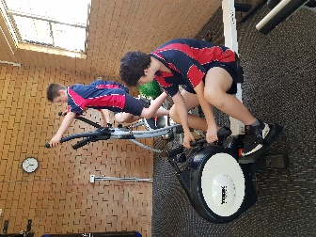 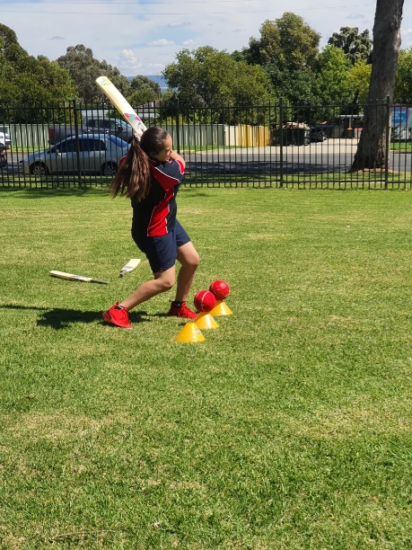 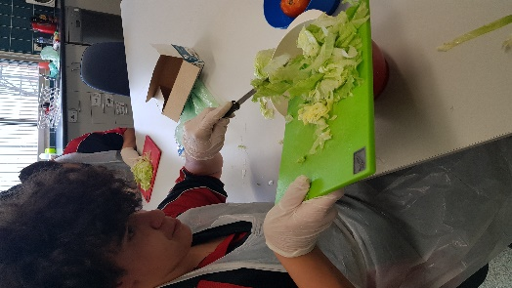

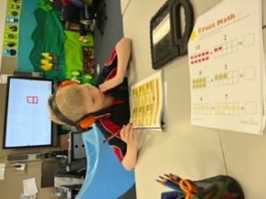 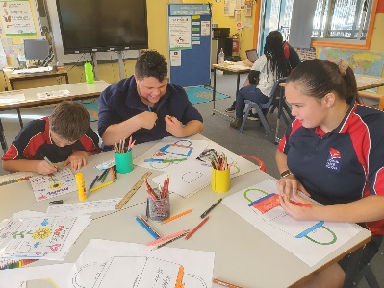 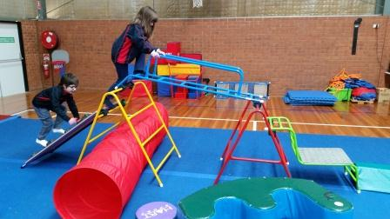

**Community Activities**

Students at Holman Place School participate in a wide range of community activities. In winter they participate in *Riding for the Disabled*. They also attend varied excursions, shopping, concerts, performances. Our programs give students the opportunity to be a part of the wider community through their experiences to learn how to behave and socialise.

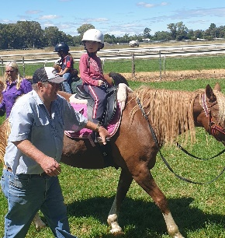 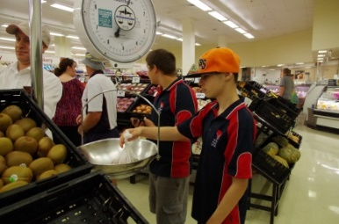

**Travel to/from School**

Students are driven to and from school by parents/carers or a local bus service. Alternatively, Assisted School Travel is available to **eligible** students on the school’s bus picking up and dropping off to family home. For further information regarding eligibility and forms, please contact school office.

**School Newsletters, Website and Facebook**

Newsletters are sent home three times per term and contain class happenings, coming events, points of interest, information from the P&C and updates from the Department of Education and Communities. Other notes for families are also distributed to students as required. Please check your child’s bag daily for any newsletters or notes. We also have a very comprehensive website [www.holmanplac-s.schools.det.nsw.edu.au](http://www.holmanplac-s.schools.det.nsw.edu.au) and Holman Place School Facebook page to keep everyone up to date on the latest happenings.

**P&C Association**

The Parents and Citizens Association supports the school through fundraising help students through resources and activities. The P&C work for the whole school and can only be successful if it has the support of all families. The P&C meet at the Cowra Council Chambers on the 2nd Tuesday of each month from 9:30 to 11:00 am.

**School Uniforms**

The school supports the wearing of correct school uniform to foster pride in the school and maintain neatness and consistency. School uniforms identify our students and help increase security and safety when in the community environment. The school colours are navy and red shirts, navy shorts.

**Standard School Uniform** is to be worn at school and for community outings such as excursions, eisteddfods, horse riding and shopping. All uniforms are available at Mr Embroidery. Navy tracksuits for winter.

**Girl’s Standard Summer Uniform**

Navy and red shirt with school emblem. Navy shorts or skorts. School hat.

**Boy’s Standard Summer Uniform**

Navy and red shirt with school emblem. Navy shorts. School hat. Example of summer uniform.

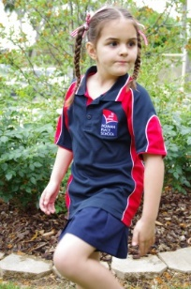

 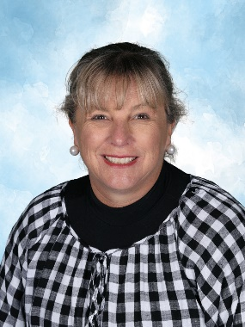 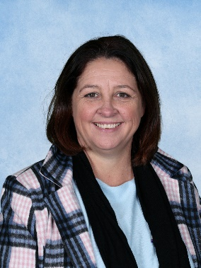

Rebecca Halls Kylie Webster Amylee Knight

Principal Asst. Principal Asst. Principal